Arrie Goforth Elementary- Marvelous Art Activities to do at Home
I hope that you’ve had some time to rest, play, and do lots of what you like to do. I’ve been watching Netflix, cooking, talking to old friends, and working in my garden. I’ve also been thinking about you. In this next few weeks, or as long as we’re at home, let’s get creative and do some art. I’ll take pictures of what I do and share them with you any time that you send me an email or text.
I’ll respond with a comment if you tag me in a message on Instagram.
You can also send me a video clip on the Marco Polo app (it’s so easy to use),
or a document or slide show of what you’ve created using Google Slides or Docs (share to my school email address).

I’d love to see what you’re dreaming up, and will answer you, usually within a day.
I will also begin uploading some ideas on the school’s GT website. I’ll make an art page there.
Use whatever works best for you, and I’ll be excited to see your creations!!
Julie Hartle
972-571-3032
julie.hartle@norfork.k12.ar.us

Note to parents:
I am providing choices for students so that you/they may choose activities that interest them from the supplies you already have at home, which will vary from family to family. I have included all grade levels, as a sibling or parent may choose to help a younger child with a more challenging project, or you may want to modify any activity to fit the interests and needs of your child. Feel free to do one each week, or as many as you’d like. I’ll add more ideas to the school website in the coming weeks. Feel free to call, text, or email me questions.

You may also want to consider setting up a designated place in the house (a table on the porch, a child’s desk in their bedroom, the kitchen table covered by a plastic tablecloth, tarp, or trash bag) to do art. It can be messy! You might consider gathering supplies you want your child to use into a box, pan, or other container that they can carry supplies to or keep in their spot.

Suggestions: pencils, erasers, pens, crayons, markers, scissors, glue, paper, paints, brushes, natural objects, craft papers, clay, play dough, clean old rags (for clean-up), recyclable objects, water containers, egg cartons, old spiral notebooks or journals, scrap fabric, chalk…

K-2nd grade students (and older kids, parents, grandparents, me…):

My special hands
Take a piece of paper, and trace your child’s hands with a pencil, three times. Overlap the hands. Instruct kids to trace hands with a black sharpie, marker, or crayon. Talk to them about patterns, and practice some together. Next, give them colored sharpies, markers, pencils, or crayons to draw patterns on the hands. Finally, have kids pick one color to paint or color the background.
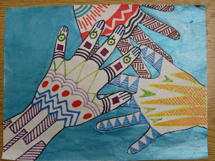

Tissue Roll Animals
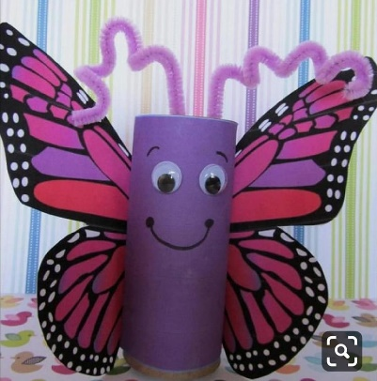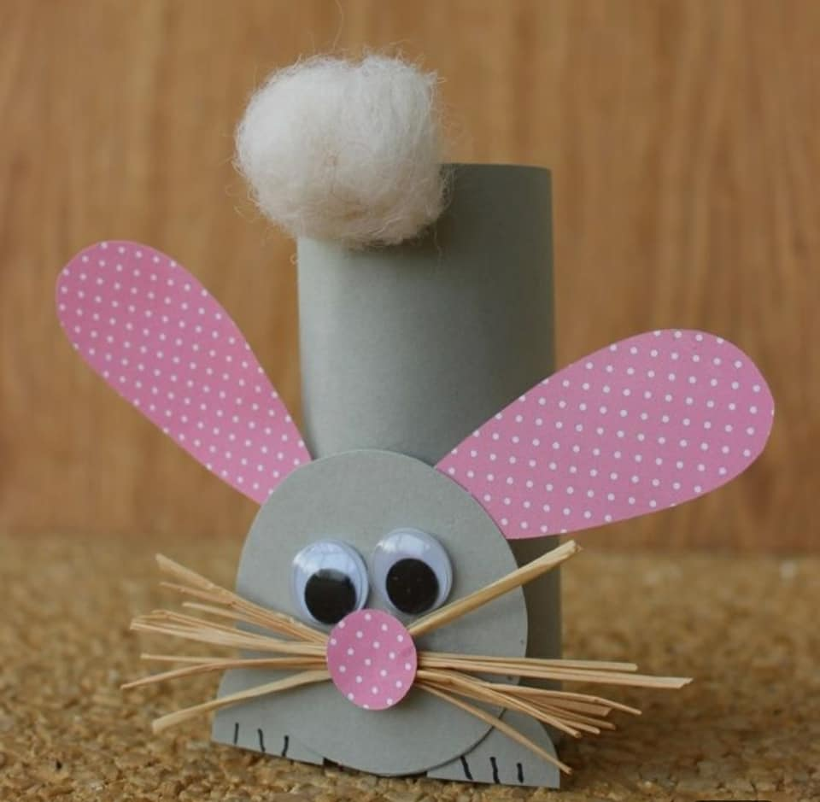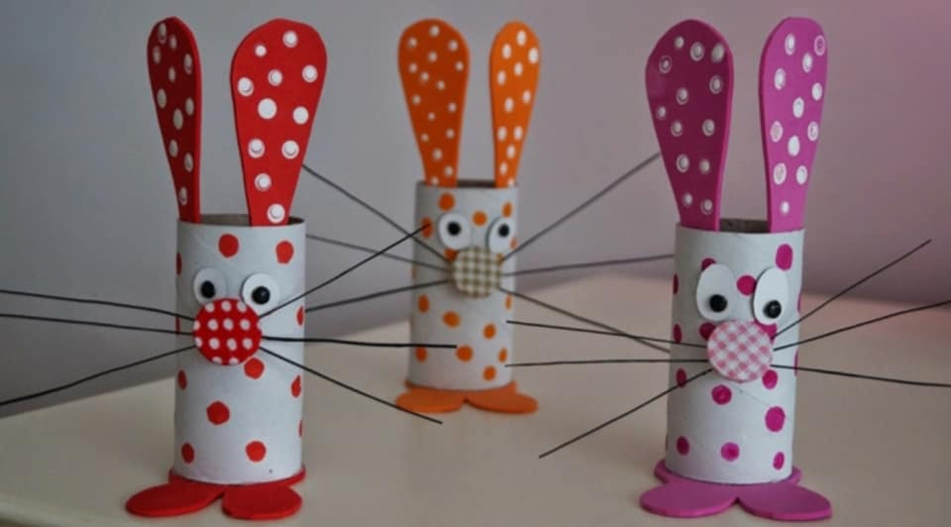

Use whatever materials you have at home to make some cute animals. Make a zoo, decorate the house, or put on a puppet show with them.

Clay Impressions
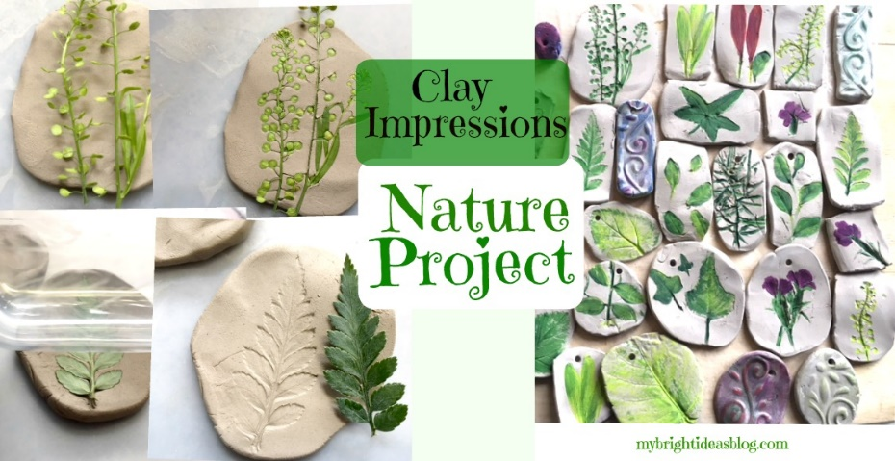
Make some clay using one of these recipes, or one you find online:

A) Stir together ½ cup salt, ½ cup water, 1 cup flour- mix until smooth

B) Air Hardening Modeling Clay- requires adult help to cook
1 cup baking soda
½ cup cornstarch
¾ cup cold water
Baking soda and cornstarch make a smooth, pliable play clay that can be colored with everyday food coloring - or left white and painted once it hardens. When you have made your model, leave it to air dry, turning every 12 hours or so.
Place ingredients in a pan and stir until smooth. Have an adult set the pan over a medium heat and stir until boiling. Stir out any lumps and cook until it is the consistency of mashed potatoes.
Turn out onto a plate and cover with a damp, well-wrung kitchen towel - let cool. Dust a work surface with cornstarch and knead until pliable- elastic and soft.

Gather some interesting plants or flowers from your yard with a parent, or ask your parent for a few clippings from a houseplant.

On a smooth surface like a plastic table cloth or a very smooth kitchen cutting board, use a rolling pin or water bottle that has smooth sides to roll out 3-6 inch shapes from bits of dough.

Press a plant into your dough shape, using the rolling pin or water bottle to flatten and make an imprint.
Carefully remove the plant. Use a toothpick, if needed, to lift it out.
Make a hole in the top if you will want to hang your masterpiece up.

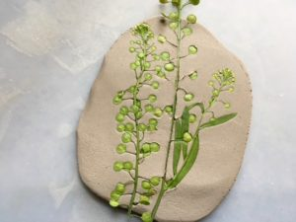
Let the dough dry, then carefully color the plant with a marker or paint, if you like. So pretty!

Shape Owl
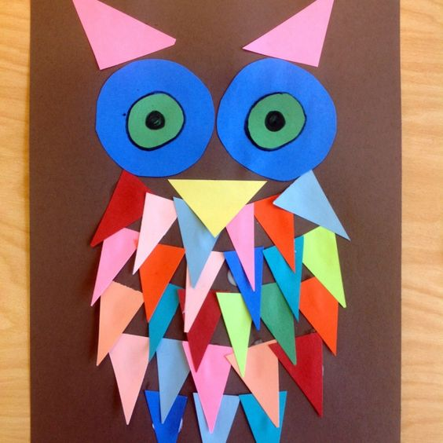
Use the bottom of a can to draw two circles on a piece of paper. Cut them out.
Draw two smaller circles, and cut them out.
Cut out triangle shapes from any kind of paper- magazine pages, old homework, scrapbook paper (ask mom/grandma for some), or colored paper.
Glue your owl eyes, nose, ears, and feathers onto a piece of paper.
Color, if you like.
Try making some other shape animals, too!

Drawing Detail
Draw something that you see. Focus on the details.
Look at it carefully again. What else do you see?
Try to draw in all the details you can add in 10 minutes.
Color your picture carefully to make sure that you can still see the details.
Share your picture with someone in your house. Tell them what you saw.
Draw another picture (today or another day) with someone close to you. You
should both look at the same thing, and draw at the same time.
How are your pictures different? How are they similar?

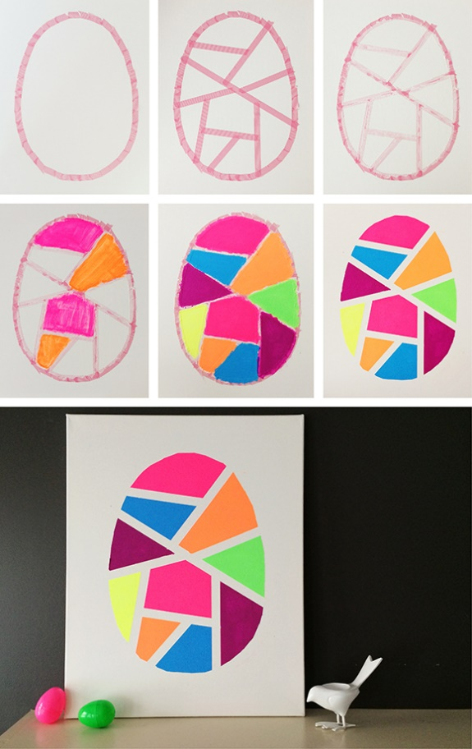
Bright Egg
You can make this egg several different ways. Try one, or try them all!
1) Draw an oval.
Lay tape across the egg to make geometric shapes.
Color or paint inside the spaces with bright colors.
Remove the tape.
2) Draw an oval.
Use a ruler to draw lines inside the egg to create geometric shapes.
Color the shapes with bright colors using a marker or crayon, or make
softer colors with colored pencils.
Cut out the shapes.
Glue them onto a new piece of paper, leaving a small space between pieces.
3) Draw an oval.
Use a ruler to draw lines inside the egg to create geometric shapes.
Cut out the outside of the egg.
Lay the pattern over another sheet of paper, or a brightly-colored magazine
page. Cut out one shape.
Repeat with each shape inside the egg.
Lay the puzzle-like pieces of colored shapes on a new piece of paper, and glue
them down.

3rd-6th graders (and younger students, with help):

Nature art:
If you have a place where you can go outside safely, with your parent’s permission and without being near others, gather some of the following natural objects to make art from found objects. If you can’t go outside safely, use small recyclable or craft objects, again with your parent’s permission, to make something cool.

Outside, gather leaves, small twigs, bark, wildflowers, and tiny/small stones.

Inside, collect small lids, string, buttons, small pieces of fabric, paper, tin pans,
candy wrappers, cracker or cereal boxes to cut, foil…

Think about the shapes and colors that you have, then arrange the objects to make a picture. Take a picture, then use your treasures to make something else. Glue your favorite picture down to save. Have fun!

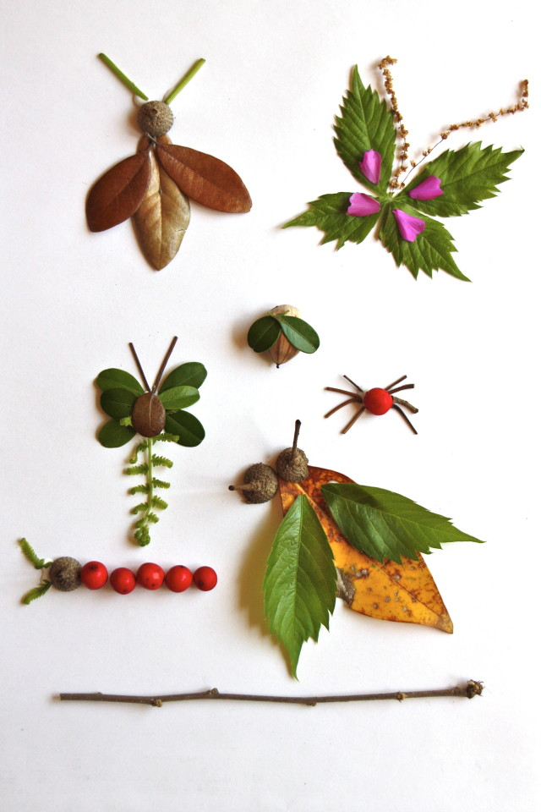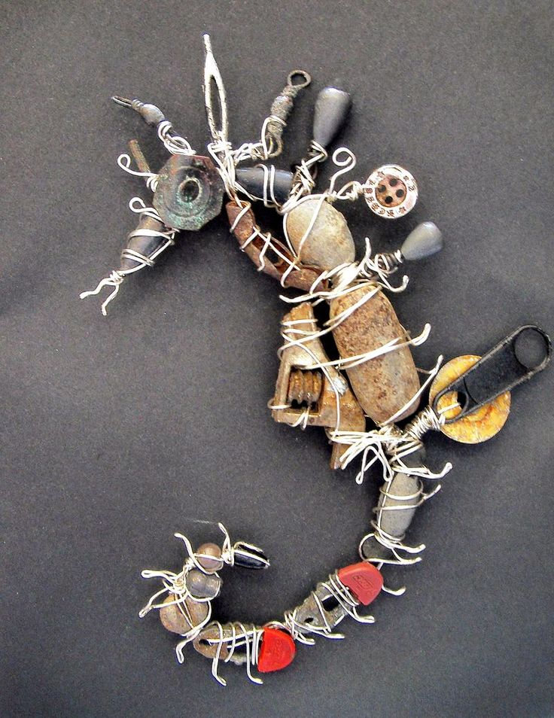

Paper Plate Weaving

Materials: paper plate, ruler, pencil or pen, scissors, yarn

Using a pencil and a ruler, draw 8 lines that cross through the center of a paper plate, dividing it into 16 equal “pie wedges.” Label each line consecutively with numbers from 1 through 16. If you want a looser weave, you can divide the plate into a smaller number of wedges (draw 4 lines across the plate to make 8 wedges). Similarly, a tighter weave will require a greater number of wedges.
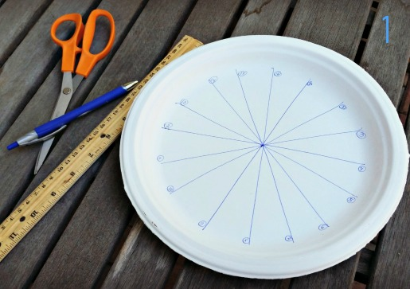
Use scissors to snip around the edge of the paper plate at the end of each line. Fasten the end of the yarn at line 1. Stretch the yarn across the top of the paper plate and fasten at line 9.
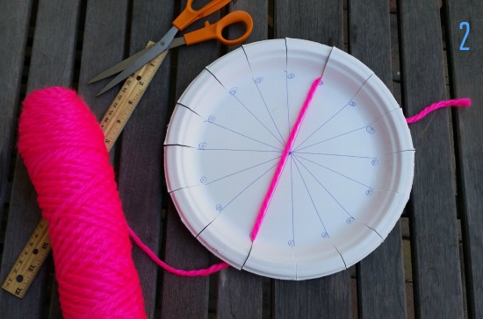
Wind the yarn around the back of the paper plate and fasten at line 10. Continue winding the yarn across the paper plate, fastening the yarn at each line in the following order: 2-3-11-12-4-5-13-14-6-7-16-15-8-9.
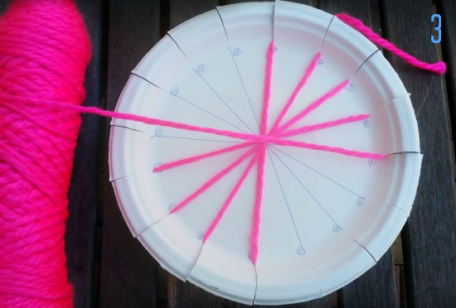
Note: Do not wind the yarn across the bottom of the paper plate, only across the top. The bottom of your paper plate should look like this:
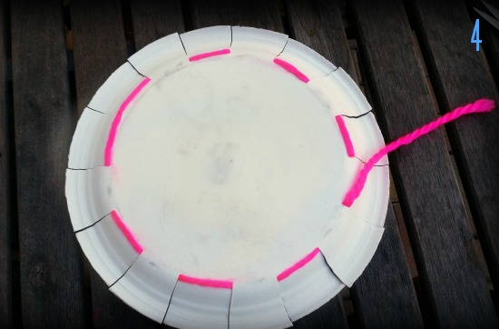
You should now have a “yarn wheel,” with 17 yarn spokes radiating outwards from the center of the circle (line 9 has 2 yarn spokes).
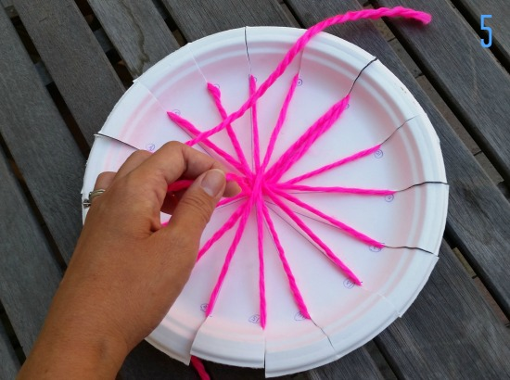

The loom is ready, now it’s time to weave!
Cut an 18-inch length of yarn. Tie one end to the center of the yarn wheel. Begin to thread the length of yarn through the yarn spokes, in an under-over-under-over pattern (begin by passing the yarn underneath line 1, over line 2, under line 3, etc….)
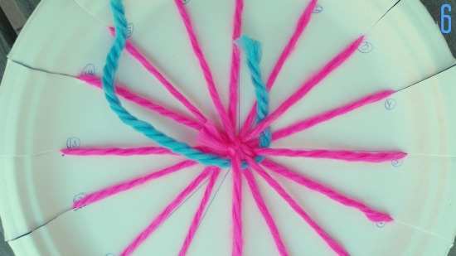
Because your yarn wheel has an odd number of spokes (17), your under-over-under-over pattern will reverse itself once you get back to line 1 (over line 1, under line 2, over line 3, etc….), producing a simple weave pattern.
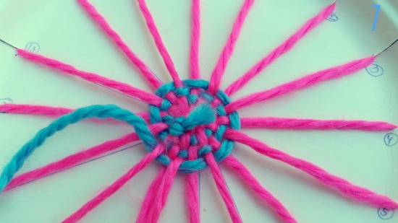
When you get to the end of the yarn, simply cut another length and tie the new yarn to the old yarn. If you want to make a concentric ring pattern, use a different color of yarn! As your circle grows bigger, you’ll need more yarn to weave your way from line 1 to line 17, so if you want to keep your concentric rings at an equal thickness, you’ll need to cut a longer length of yarn each time you switch colors.
Another tip: to keep your circle nice and flat, avoid pulling the yarn too tightly.
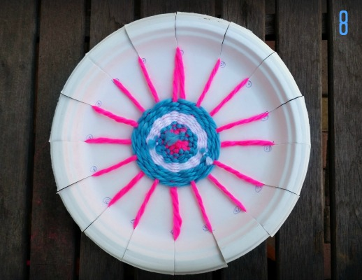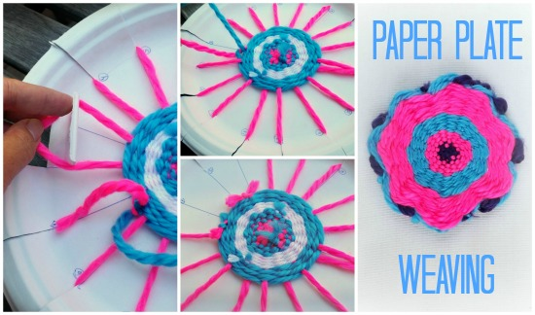
Keep weaving all the way up to the edge of the plate. To finish it off, simply tie the end of the yarn to one of the yarn spokes and pull each of the yarn spokes away from the plate. If you want to make a smaller circle, tie the end of the yarn to one of the yarn spokes. One by one, pull each of the yarn spokes away from the plate, cut them in half, and tie the two ends together. If you want to make a flower instead of a circle, pull the two ends together more tightly, which ruffles the edges and gives it a petaled look! These woven circles or flowers make adorable pot holders, door hangers, and coasters! Ana Picazo
Learning from Artists:

Practice drawing doing one, or all, of the following:
A) Find a picture that you like in a magazine or book. Use it as a starting point.
Take your time, and draw it with as much detail as you can. Don’t worry if it
looks different- every artist has their own style, and sees things in their own
way. Unique is terrific!
B) Look around your house or backyard. What catches your eye? Is it odd,
beautiful, or intriguing? Move it where there is nothing in the background, if
possible. Can you draw it?
Change your position, and try drawing it from a fresh perspective.
Shade or color, if you like.
C) Find a photo that you like in an album, on the wall, or online.
Take your time and draw it as realistically as you can.
Color or shade your picture in whatever way you like.
D) Look up famous artists or works of art online. Consider going to a famous
museum’s website, such as The Metropolitan Museum, The Kimball Art
Museum, The National Gallery of Art, Rijksmuseum, or The Louvre Museum.
Then do what the masters did- copy and learn from the best!
E) Draw a live model- someone in your family

Fold an Origami Frog

Watch the following video to learn to fold a jumping frog:
https://youtu.be/rht7y5kooJQ

Follow the other origami links that pop up to fold other animals, or search for origami directions. Create a zoo, make a game, or have a contest with your brothers and sisters or parents. Have fun!

Photographic Diary

This art lesson is going to be spread throughout the day, or even the week. You can use a phone, iPad, or camera to do this project. This diary will have no words because, as the saying goes, “A picture speaks a thousand words.” You might want to focus on the environment around you. (Buildings, interiors, landscapes). Or your photographic diary might be all about the people in your day, or your activities. It can be about your hopes for the future, or what you value most. Be as creative as you like. You can make a slide show to share, a video using an online app, or make a digital collage. You can print them, cut them out, and make a montage, vision board, or scrapbook. Make it memorable. Make it yours!

Painting with Coffee
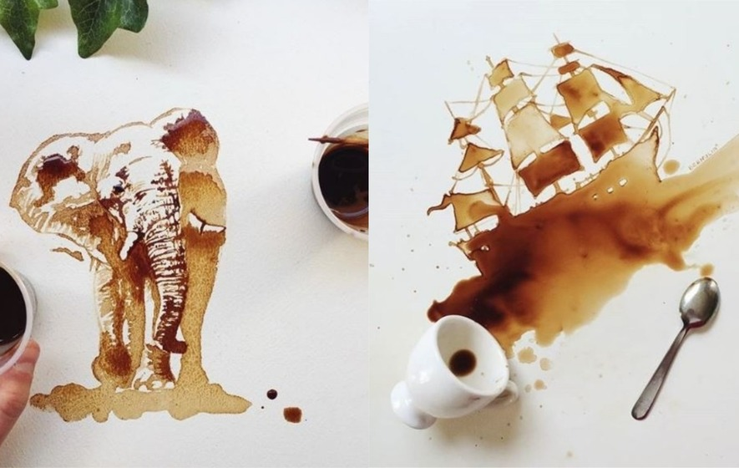
Look at the artwork of Giulia Bernardelli. She paints pictures with coffee. Ask your parent to make some strong coffee, so that it is really dark. Using a spoon or a variety of tools you can find in the kitchen, paint a picture with coffee. Bernardelli lets the coffee spill onto the page and then sees what it reminds her of. Add details with a pencil, pen, or maker.

